MySQL Assignment 2
clauses & joins
name: Aswathi ravi, Batch: da60
MySQL Assignment 2 – Querying Data
- Continue from the previous assignment (database & table creation with constraints).
- Use the provided DML insert codes to populate the tables from Employee Data
- Execute the queries in this assignment after inserting the data.

Inserting Department Records
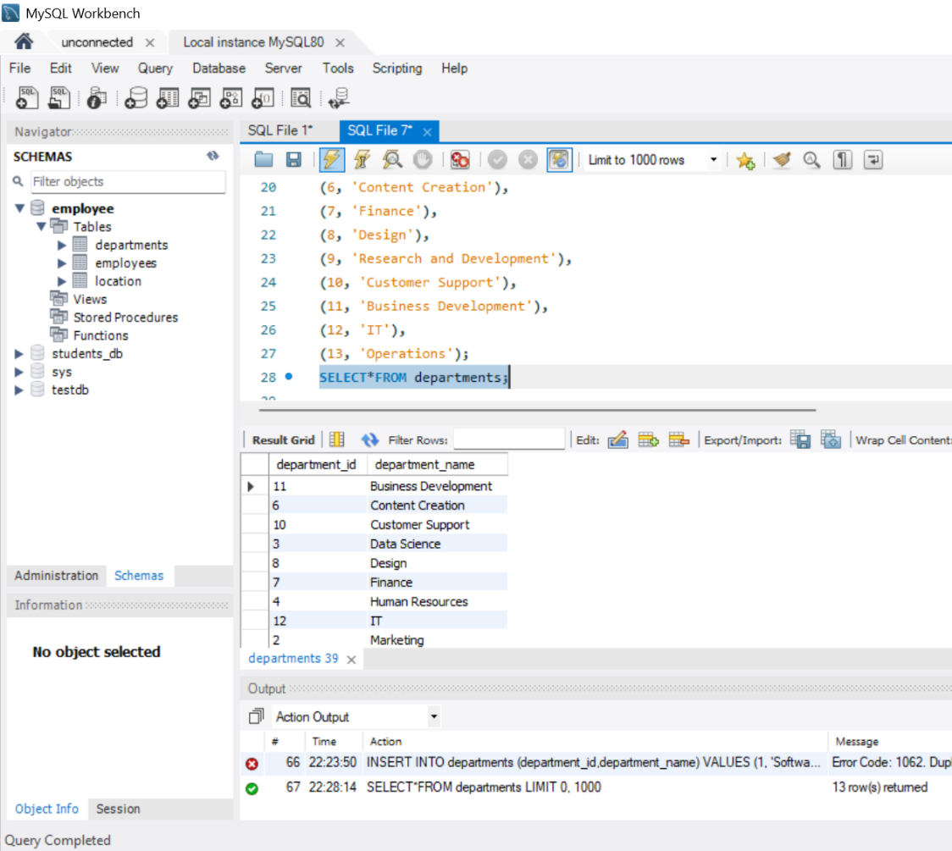

Inserting Location Records
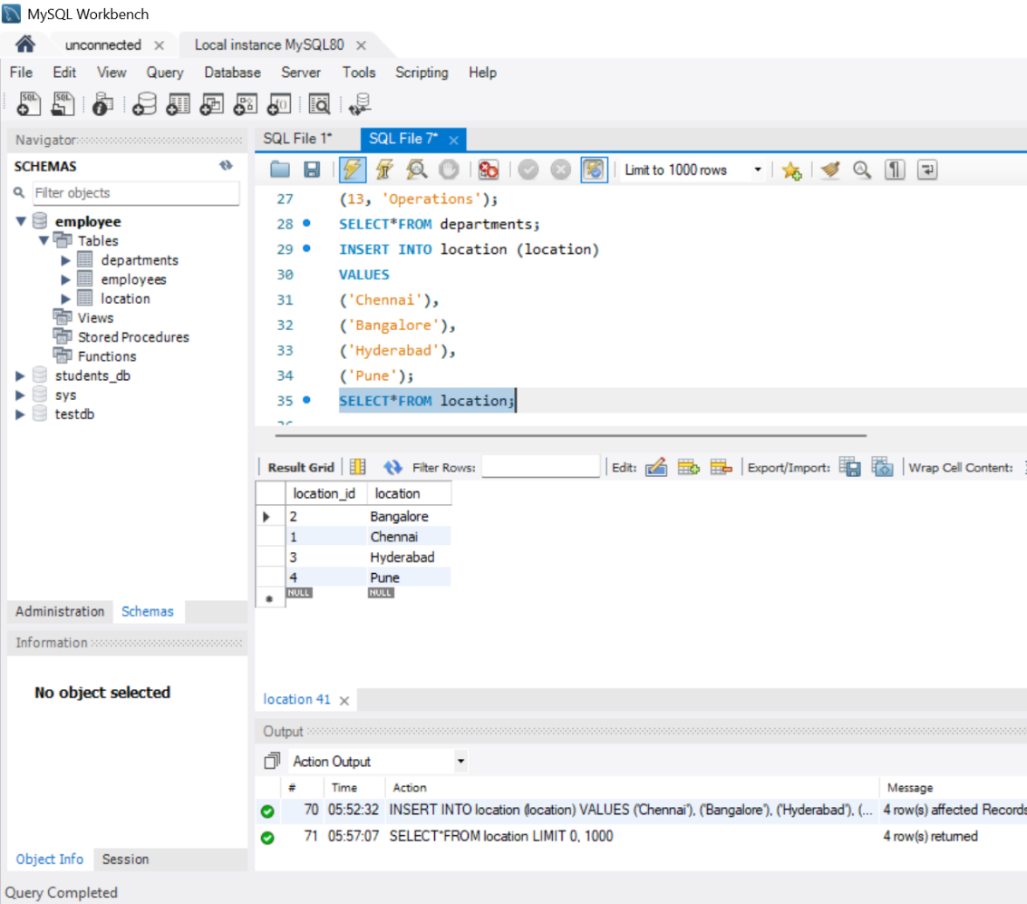

Inserting Employee Records
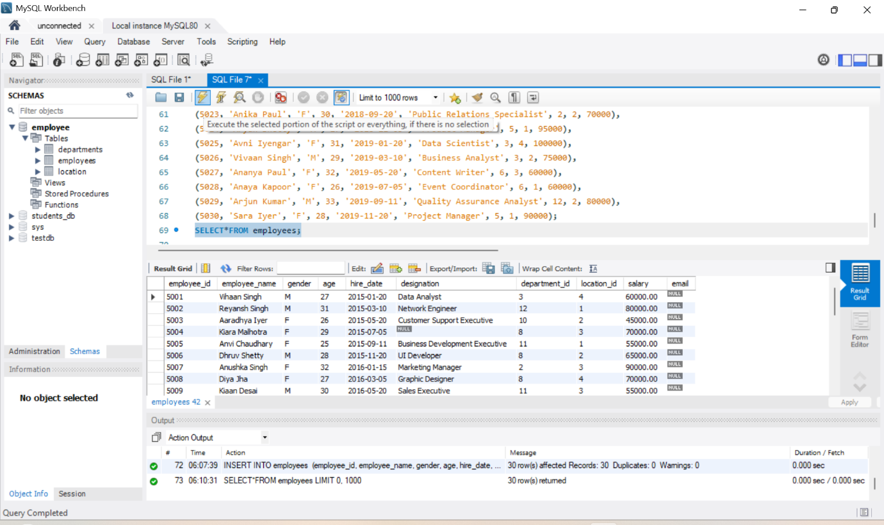
- Distinct Values:
- a query to retrieve distinct salaries from the Employees table.
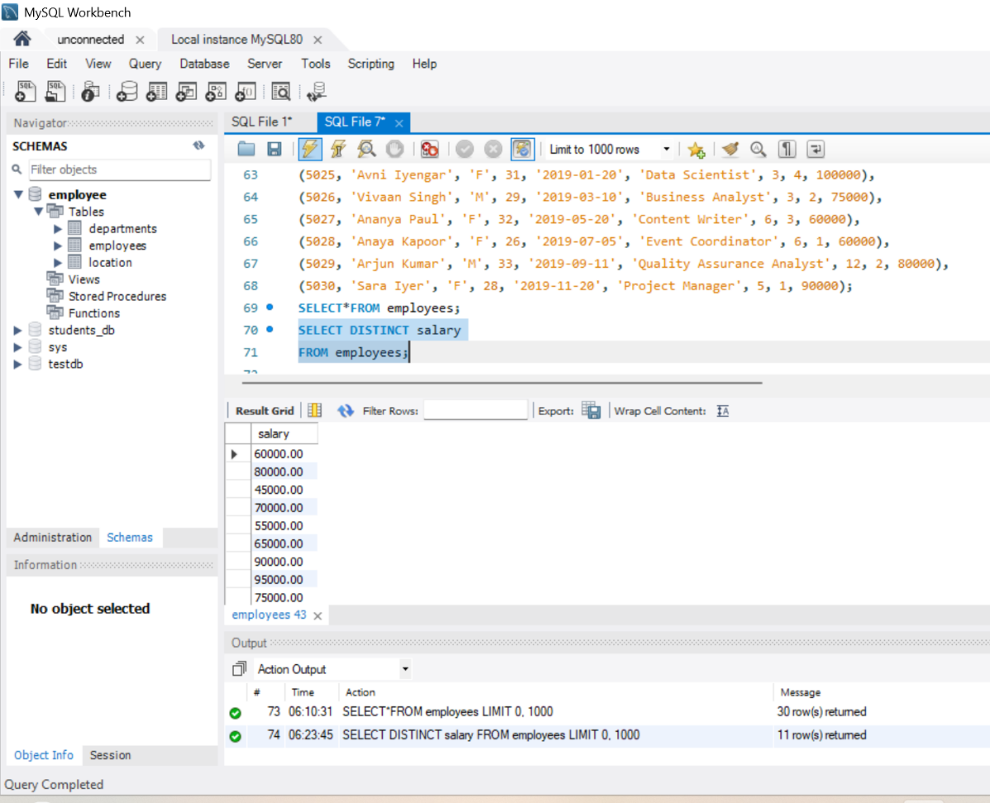

- Alias (AS):
- Provide aliases for the "age" and "salary" columns as "Employee_Age" an "Employee_Salary", respectively.

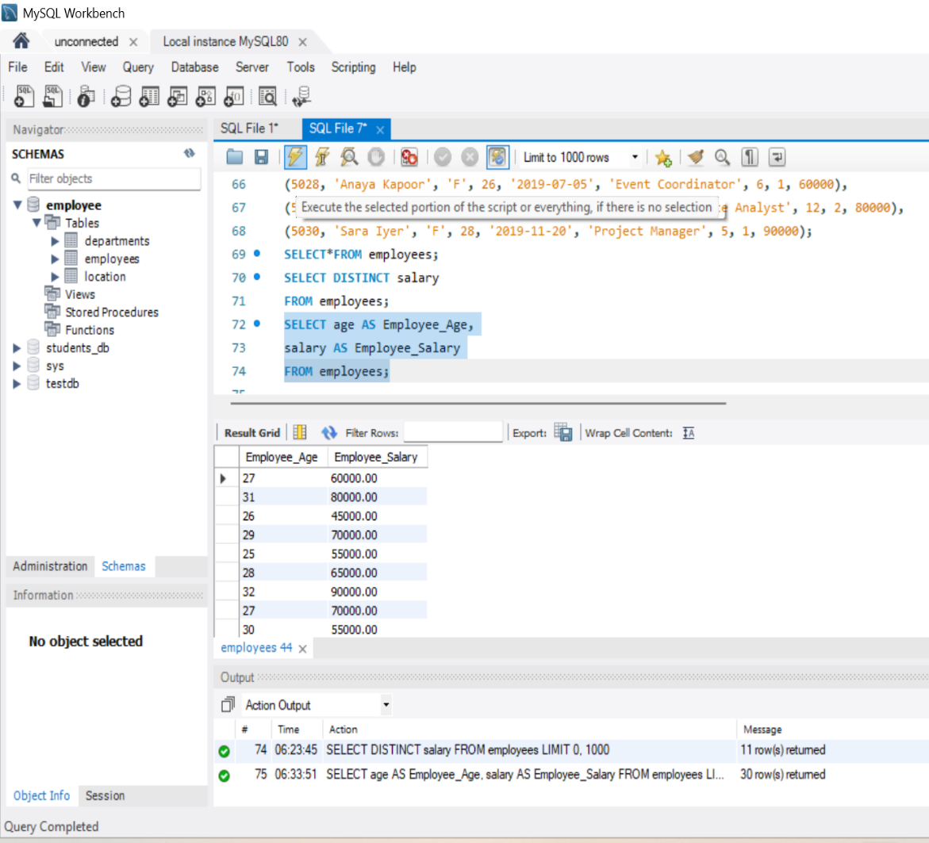

- Where Clause & Operators:
- Retrieve employees with a salary greater than ₹50000 and hired before 2016-01-01.
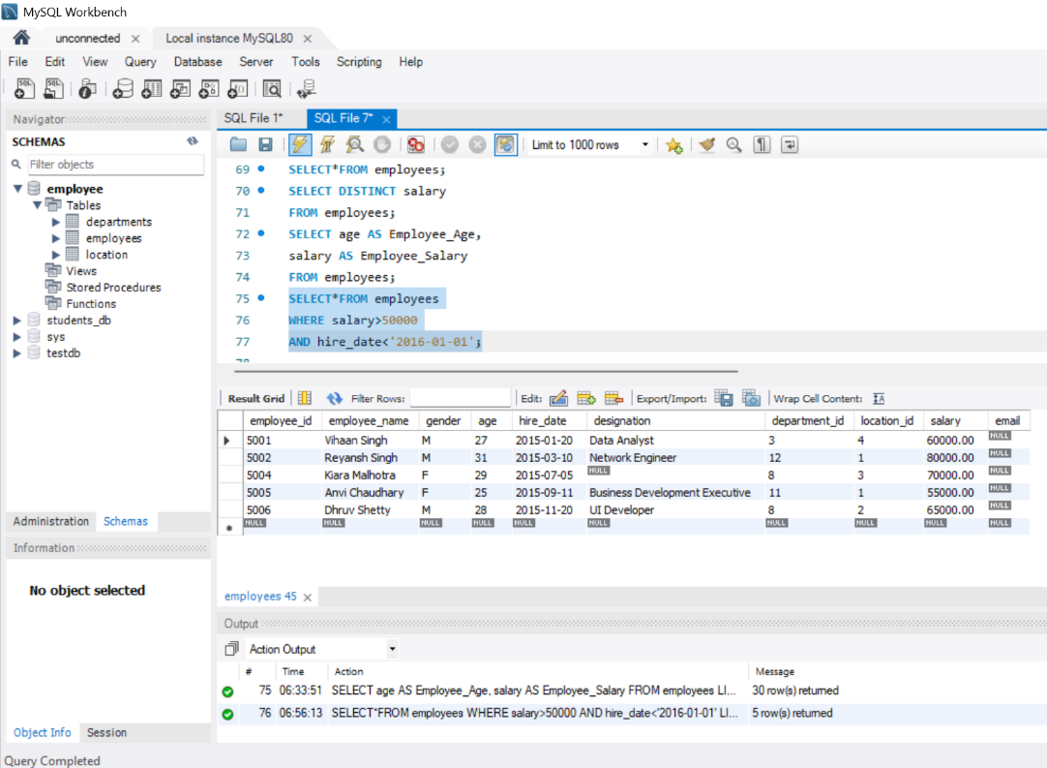

- Find the employee whose designation is missing and fill it with "Data
Scientist".
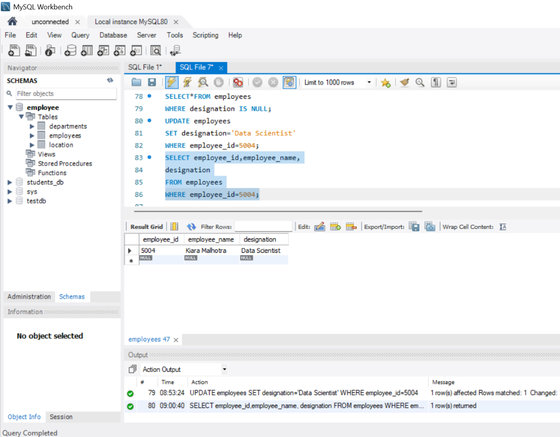

Sorting and Grouping Data:
- ORDER BY:

- Find employees sorted by department ID in ascending order and salary in
descending order.

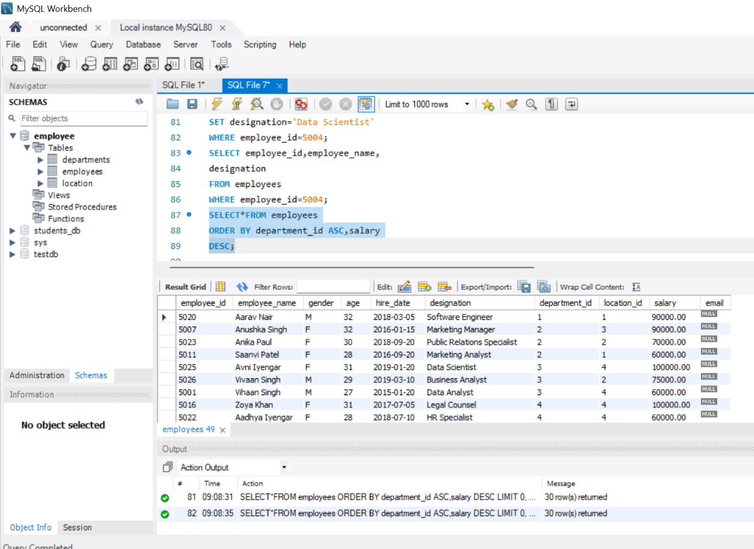
- LIMIT:
- Display the first 5 employees hired in the year 2018.
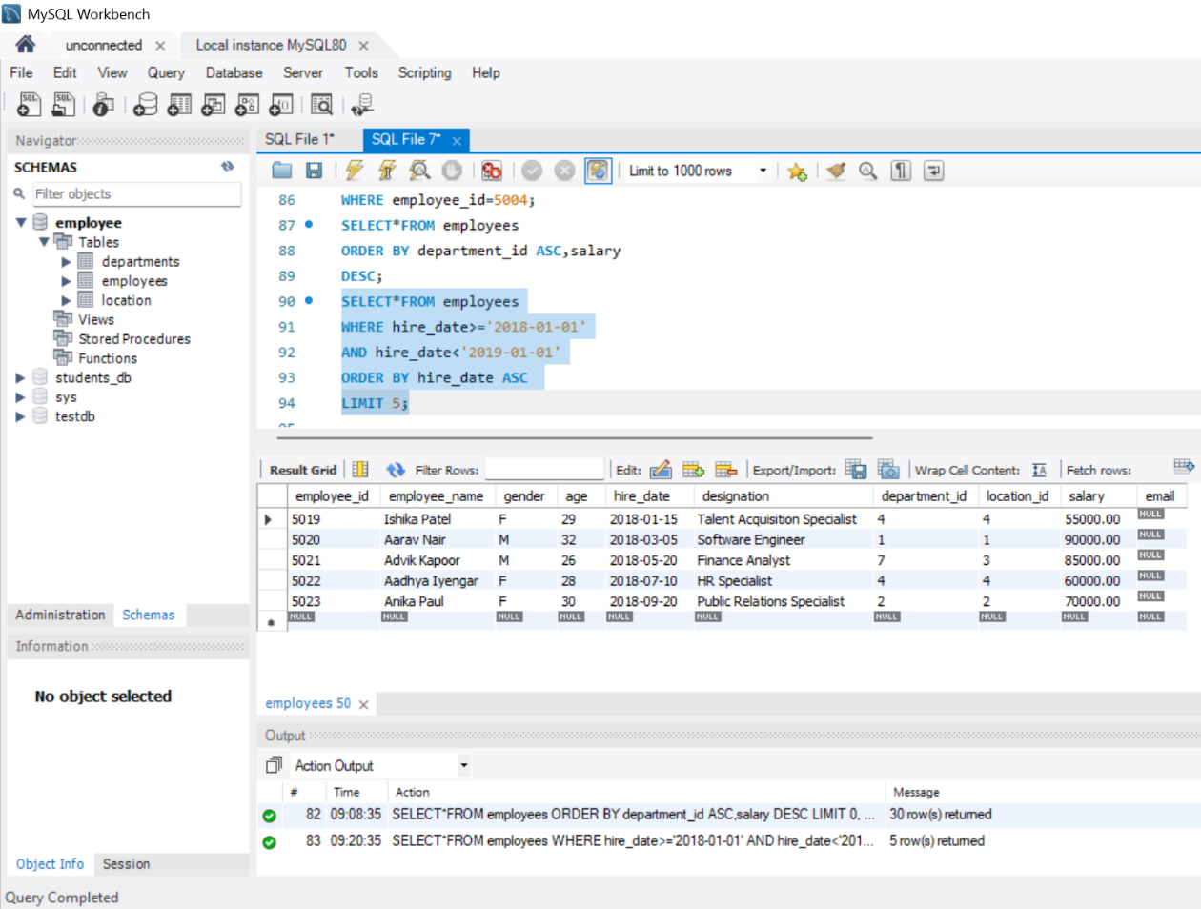

- Aggregate Functions:
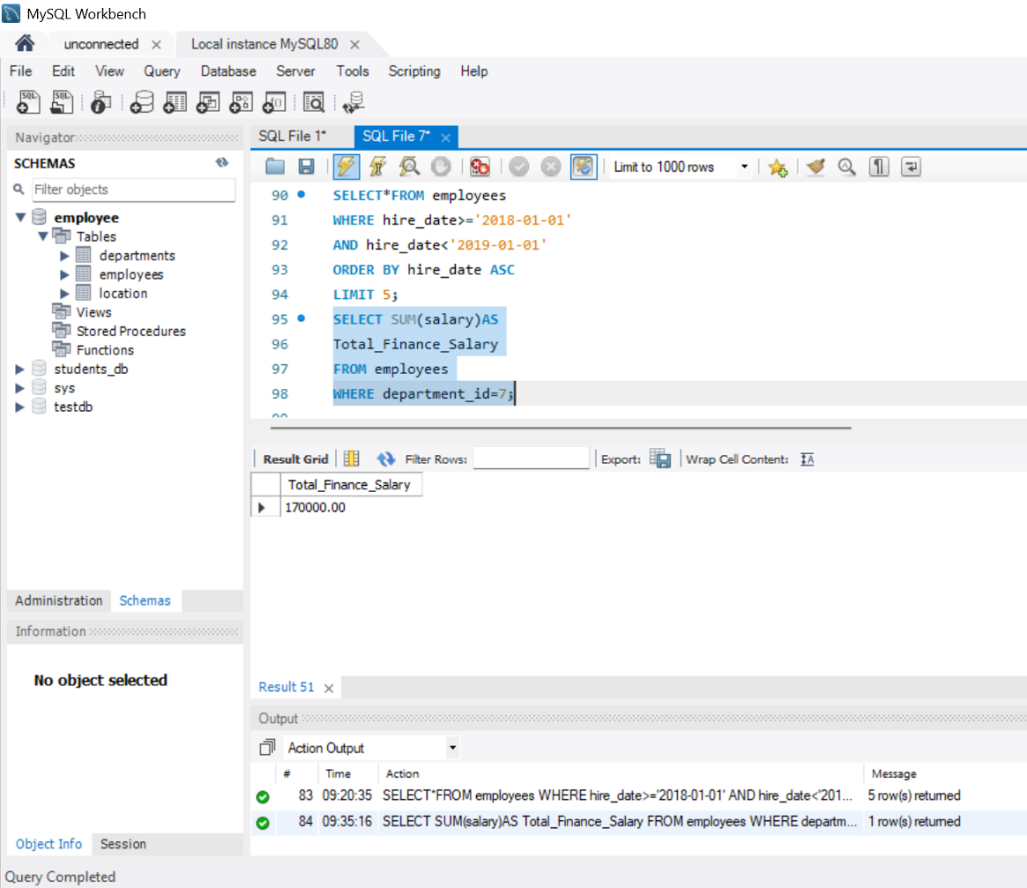
- Calculate the sum of all salaries in the Finance department.

- Find the minimum age among all employees.
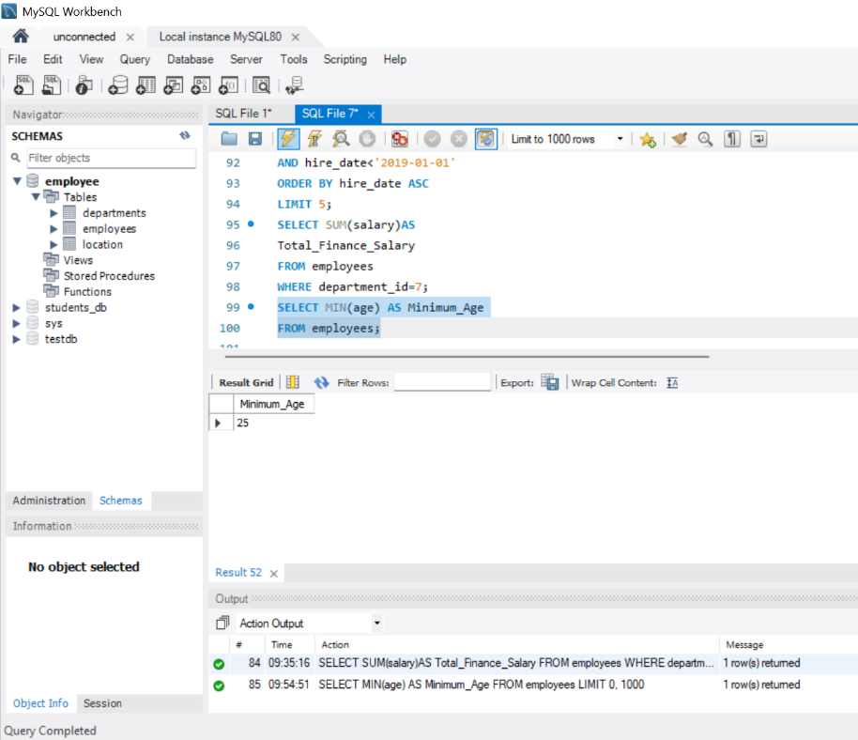

- GROUP BY:
- List the maximum salary for each location.
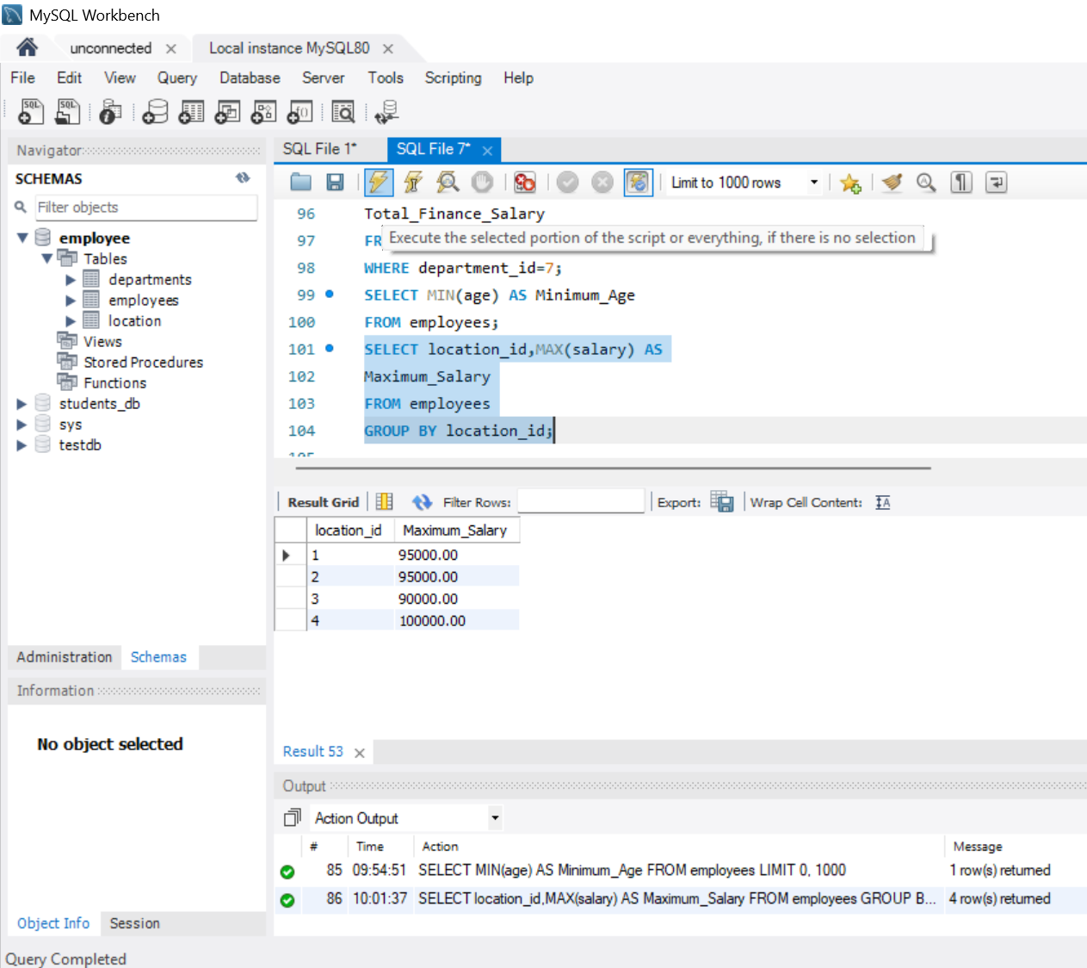

- Calculate the average salary for each designation containing the word 'Analyst'.

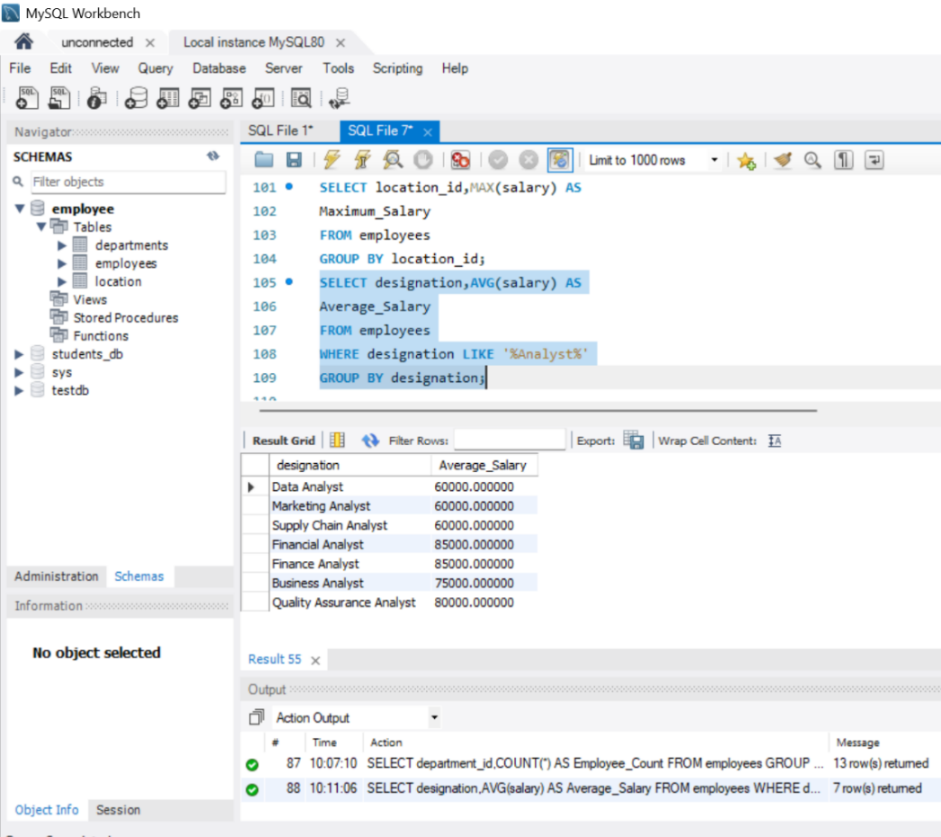

- HAVING:
- Find departments with less than 3 employees.
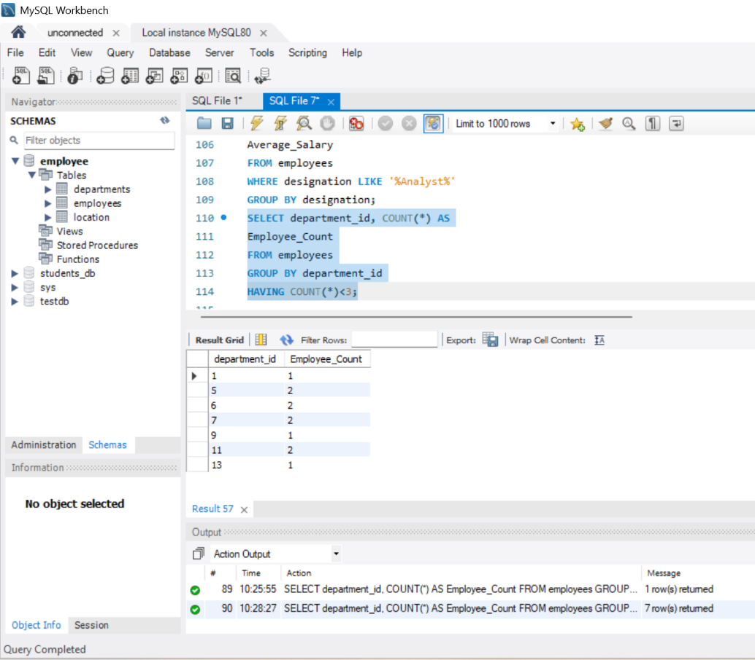

- Find locations with female employees whose average age is below 30.
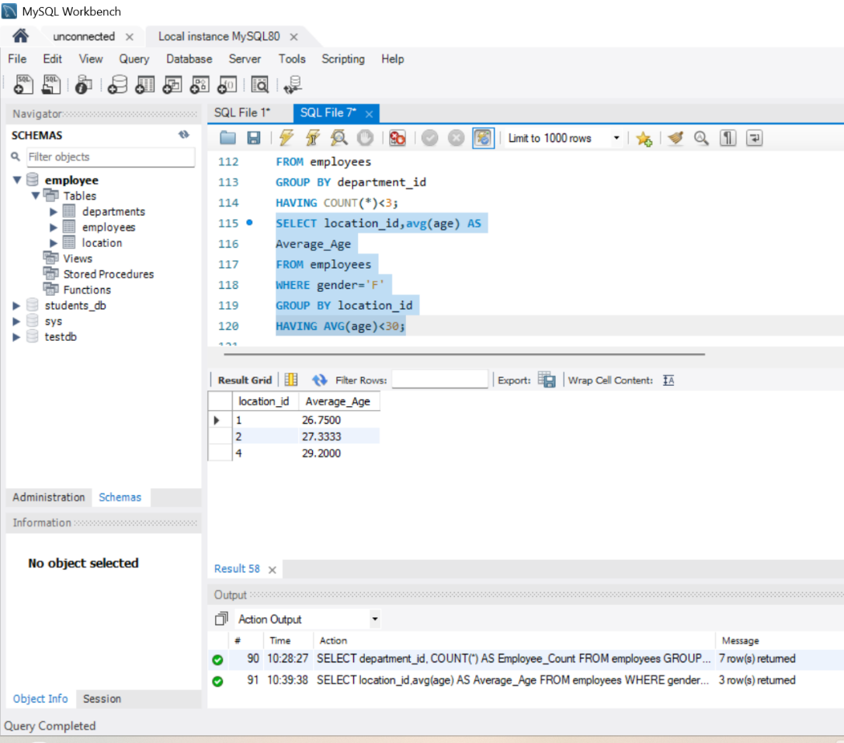

Joins:
- Inner Join:
- List employee names, their designations, and department names where employees are assigned to a department.

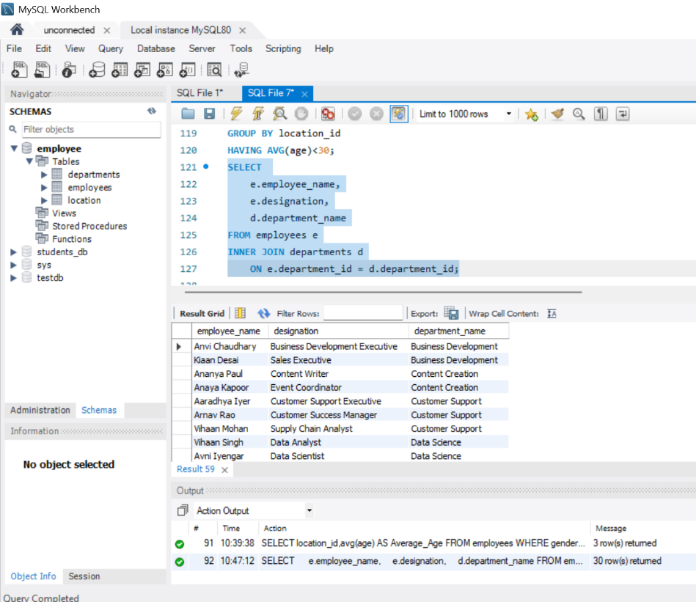

- Left Join:
- List all departments along with the total number of employees in each department, including departments with no employees.
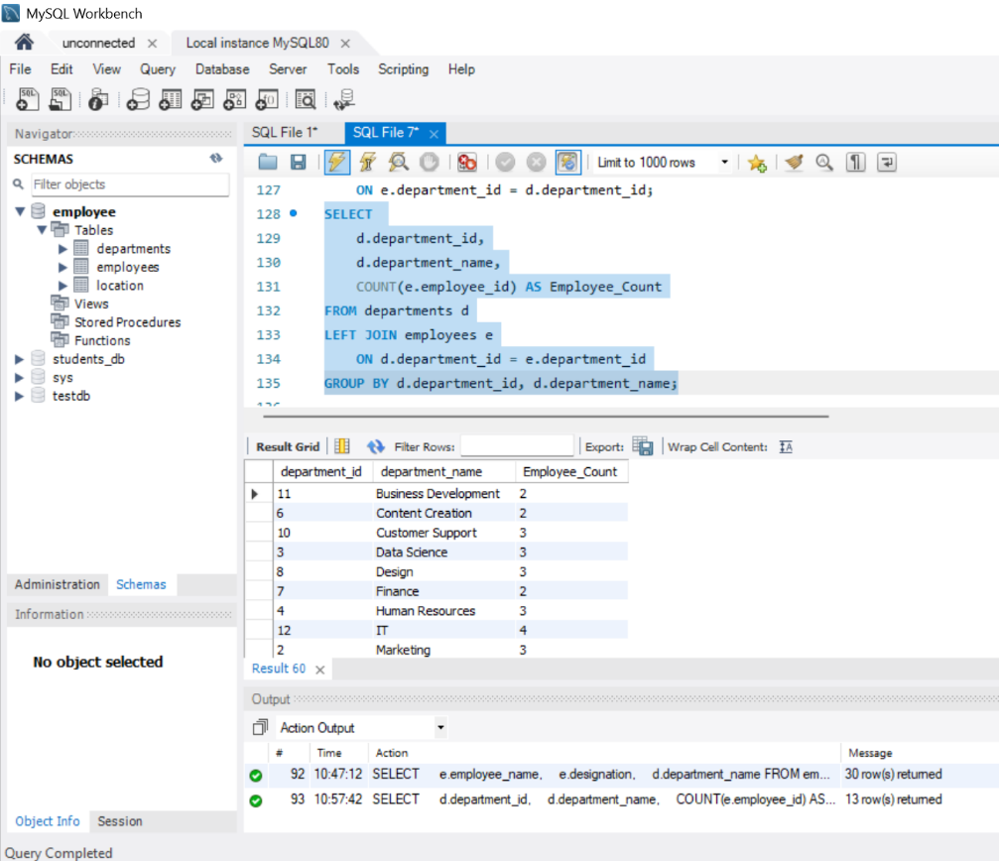

- Right Join:
- Display all locations along with the names of employees assigned to each location. If no employees are assigned to a location, display NULL for employee name.
